Product Brief

Linear Microsystems Overview
- Fabless semiconductor company
- Founded in 2013
- Design & production of high-performance RF, analog, mixed-signal, and SoC ASICs
- Expertise in Hall Effect, piezoelectric, pressure, temperature, gas, magnetic, optical and various types of medical sensors
- Markets include medical, automotive, industrial, aircraft, and military
- Very Seasoned engineering team
- Key management & technology team together for over 20 years
- Partnered with technology leading foundries & packaging vendors

Linear Microsystems, Inc. (LMI), is a full-service ASIC company located in Irvine, California. LMI develops analog, mixed-signal, digital and RF ASICs. In particular, LMI has specific expertise in Sensor IP and ASICs.

Internal IP
Power Management
Low Noise TIA & Voltage Amplifiers
Measurement – sensing
Data Conversion – ADC, DAC, S/H
High Speed; resolution to 16 bits
Interfaces (LVDS, SPI, I²C, 2&3 wire)
Integrated µP and DSP
Timing (VCO, APLL, DLL, Synthesizer, etc.)

IP Performance
High Voltage
1200V, 650V, 300V, 100V, 20V
High Speed
>> 28 GHz
Low Power
<< 1uA
Low Noise
<< 10 nV/rt Hz, 10 nA/rt Hz
High Power
Up to 30A
Multiple I/O standards

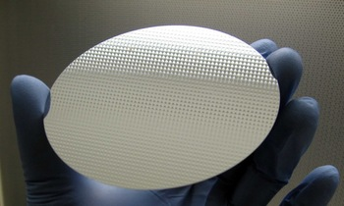
A typical 6 inch wafer

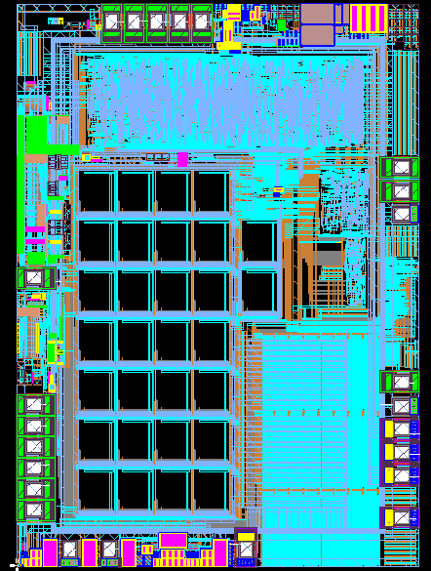

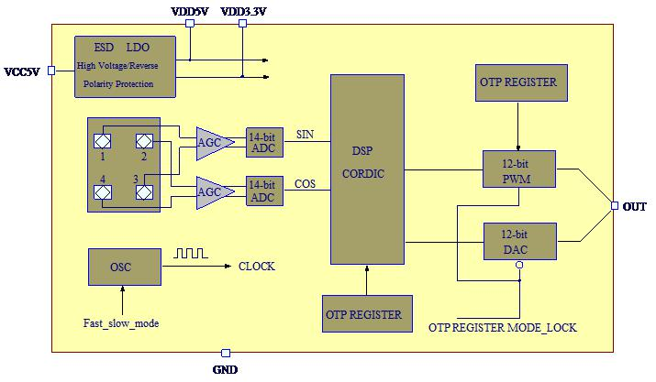

Rotary Hall Sensor ASIC
- Measures angular movement; used numerous times in every automobile
- Very high production volume
- Hall Sensor – uses existing Hall sensor IP
- Proprietary sensing circuitry/hall sensor arrangement
- Uses internal IP for 14 bit ADC, LDO, 12 bit DAC, DSP, OTP, oscillator and PWM
- 16 lead QFN with 2 identical stacked dies for redundancy
- 16 lead dual die QFN

Programmable Inductive Proximity Sensor SoC
- Analog Signal Processing, Microprocessor Controller and EEPROM
- Patented architecture based on differential LC tank oscillator
- Senses all metal target at equal and longer sensing distance through phase detection or combined phase shift/amplitude sensing
- High switching frequency
- High level of magnetic field immunity
- 3 wire DC or 2 wire AC/DC interface
- Key circuit blocks include oscillator, signal modulator, ADC, power management, short circuit protection, embedded microprocessor, SRAM and OTP (non-volatile) memories.
- Embedded processor controls various modes of operation, temperature compensation, sensor calibration, signal linearization, system diagnostics and output control
- Die Size: 1.7 mm x 2.6 mm
- Package: 24 lead 4mm x 4 mm QFN
- 180 nm CMOS

Package Options: Multi-Project Wafers for Low Cost
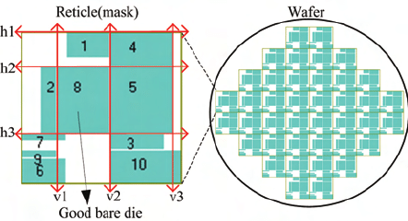
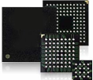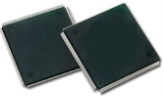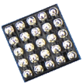

Contact: sheri.herb@linearmicrosystems.com

Distributor: EquipIC Supply Chain

doug.mcarthur@equipic.com; (408) 891-3236

